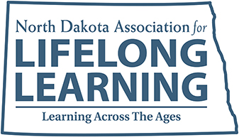
Organizational
Membership Form
v.220825

Organization_____________________________________________________________________________
Primary Contact/Title______________________________________________________________________
Mailing Address__________________________________________________________________________
City, State, Zip___________________________________________________________________________
Telephone___________________________________
Email_______________________________________Website_____________________________________
**Please attach a list of your organization’s staff members with titles and email addresses to this membership form.**
Check one category below – annual dues are based on your organization’s staff size.

Staff Size Dues
___5 staff or less $250
___6-10 staff $500
___11-15 staff $750
___16-20 staff $1000
___21-25 staff $1,250
___26+ staff $1,500

Mission
To support adult and alternative education, its educators, students and partners.

Goals
- Knowledge Sharing & Networking: Provide, promote and coordinate professional development opportunities in collaboration with local, state and regional partners.
- Member Promotion & Communication: Promote best practices in college, career and choice readiness and English language proficiency and encourage the exchange of ideas and information.
- Public Awareness: Promote adult and alternative education.
- Organization Development: Build membership and sustainable revenue streams.

Benefits
- Networking opportunities
- Discounted rates for annual conference
- Awards and scholarship opportunities
- Association communication, including monthly eNewsletter
- Membership in Mountain Plains Adult Education Association and Commission on Adult Basic Education
Complete this form, attach a staff list and mail it with your dues payment to:
NDALL
PO Box 2599
Bismarck, ND 58502

Questions:
Call 701-355-4458 or email jcollins@clearwatercommunications.net

Visit Us Online: www.ndall.info

Thank you for joining NDALL!

